BT 200: Financial Accounting

Spring 2017

Written Assignment # 3

This assignment is based on the financial statements of real companies. Each student should prepare his or her own assignment independently without collaboration. This assignment should be typed (not handwritten.) The assignment is due at the beginning of class on Thursday March 23rd.[1] In case you are unable to attend class for any reason on March 23rd, you can submit your assignment early.

**Instructions:** Prepare a report containing the following items:

1. Prepare common-size income statements (horizontal and vertical) for one of the companies listed below.

*Locate the company’s most recent Form 10-K on the SEC website* [*www.sec.gov*](http://www.sec.gov)*[2] and select “Interactive Data” and then “View Excel Document.” Download the excel document and use it to create the common-size financial statements. An idea for formatting: “Copy” the common-size statement from excel and “paste/special/picture” into your Word file.*

* Apple Inc. (NASDAQ:AAPL)
* Microsoft Corporation (NASDAQ:MSFT)
* Adobe Systems Inc (NASDAQ:ADBE)
* Starbucks (NASDAQ:SBUX)

1. Answer the following questions, using complete sentences where appropriate. *You can express amounts as thousands, millions, or billions of dollars.*
2. In the most recent year, what was the company’s gross margin, operating margin, and net profit margin?
3. Discuss the trend in the company’s gross margin, operating margin, and net margin over the past three years.
4. Briefly, how does the company explain the most recent year’s change in its margins?
5. Compare the company’s change in sales (or revenues) for the most recent year compared to the prior year, making specific reference to the horizontal income statement.
6. Briefly, how does the company explain the most recent year’s change in sales (or revenues)?

Grading Rubric

|  |  |  |
| --- | --- | --- |
| Excellent | 100 | * Complies with all requirements. * Correct information. * Content shows evidence of thoughtfulness. * Impeccable spelling and grammar. |
| Good | 90 | * Complies with all requirements. * Correct information. |
| Okay | 80 | * Complies with all requirements. * Some incorrect information. |
| Poor | 60 | * Does not comply with all requirements. * Incorrect information. |
| Unacceptable | 0 | * Incomplete or missing. OR * Uses directly quoted information without proper attribution. |

Example of Assignment using Under Armour, Inc.

NOTE: ALL DIRECTLY QUOTED MATERIAL MUST BE SHOWN IN QUOTATION MARKS AND PROPERLY REFERENCED.

*This example is based on the most recent Form 10-K available at the time of this writing, Under Armour’s 2015 Form 10-K which was filed on February 22, 2016.*

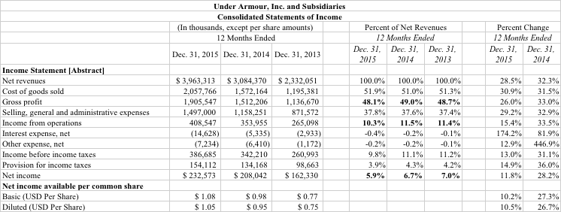

1. In the most recent year, what was the company’s gross margin, operating margin, and net profit margin?

*As shown on the vertical common-size income statement above, for the year ending December 31, 2015, Under Armour’s gross margin was 48.1%, Under Armour’s operating margin was 10.3%, and Under Armour’s net profit margin was 5.9%.*

1. Discuss the trend in the company’s gross margin, operating margin, and net margin over the past three years.

*Under Armour’s gross margin of 48.1% in fiscal 2015 was lower than its gross margins of 49.0% and 48.7% in fiscal 2014 and fiscal 2013, respectively.*

*Similarly, Under Armour’s operating profit margin of 10.3% in fiscal 2015 was lower than its operating margin in either of the two prior years.*

*Under Armour’s net profit margin has declined each year – from 7.0% in fiscal 2013, down to 6.7% in fiscal 2014, and down to 5.9% in 2015.*

*Overall, the company’s costs as a percentage of sales increased for each major line item of costs: cost of goods sold, Selling, General, and Administrative (SG&A), and interest expense.*

1. How does the company explain the most recent year’s change in its margins?

*The company attributes the 90 basis point decline in its gross margin mainly to foreign exchange rates (stronger U.S. dollar), increased freight costs, and changes in sales mix, offset by lower input costs.*

*The company’s lower operating margin (operating profit as a percentage of sales) resulted from increases in SG&A expenses as a percentage of sales, primarily costs associated with expansion of its “direct to consumer distribution channel.”*

*(Source: Under Armour’s Form 10-K. Item 7. MD&A. pages 28 and 29)*

1. Compare the company’s change in sales for the most recent year compared to the prior year, making specific reference to the horizontal income statement.

*Under Armour’s net revenues grew 28.5% in fiscal 2015. The revenue growth in fiscal 2015 was much lower than the prior year’s revenue growth of 32.3%.*

1. How does the company explain the most recent year’s change in sales (or revenues)?

*The biggest dollar changes in sales were in Apparel and Footwear. The company explains that the most recent year’s increase was driven mainly by increased unit sales and new product offerings in both Apparel and Footwear. (“Apparel unit sales growth and new offerings in multiple lines led by training, golf and running; and Footwear unit sales growth, led by running and basketball and the expansion of our footwear offerings internationally.”)*

*(Source: Under Armour’s Form 10-K. Item 7. MD&A. Page 28.)*

1. Late assignments will be penalized 10 points.
2. On the home page of the SEC, select “company filings” in the top right corner. On the next page type the company’s name. On the next page, in the box labeled “Filing type” enter 10-K.